

Name:Ali Raza
Reg no: 9864
Subject: DataBase Management System
Submitted to: Sir Zohaib Khan

Lab no 04

Q1: Update the emp table to set the salary of all employees to Rs15000/- who are working as ASP
Answer:
SQL> select * from emp;
EMPNO ENAME JOB DEPTNO SAL
---------- -------------------- ------------- ---------- ----------
1 Mehboob AP 1 10000
2 Ali ASP 2 12000
3 Gulfam ASP 1 12000

Code:
drop table emp;

create table emp (
empno number(6),
ename varchar2(20) not null,
job varchar2(13) not null,
deptno number(3),
sal number(7,2)
);

insert into emp values (9864, 'Ali Raza', 'AP', 1, 10000);
insert into emp values (9941, 'Muhammad Furqan', 'ASP', 2, 12000);
insert into emp values (10011, 'Sajjal Tariq', 'ASP', 1, 12000);
insert into emp values (10028, 'Mairah Kanwal', 'LECT', 1, 8000);
commit;

Output:
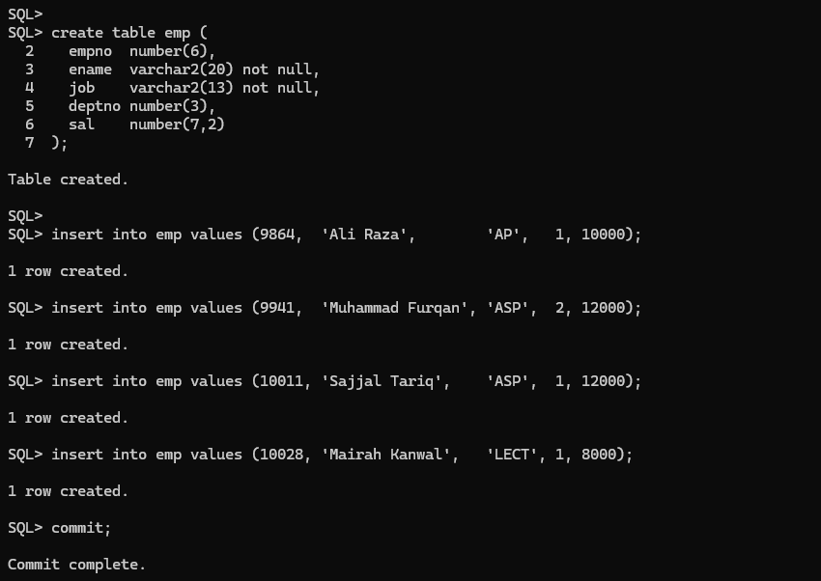

Then:
select * from emp;
update emp set sal=15000 where job='ASP';
select * from emp;

Output:
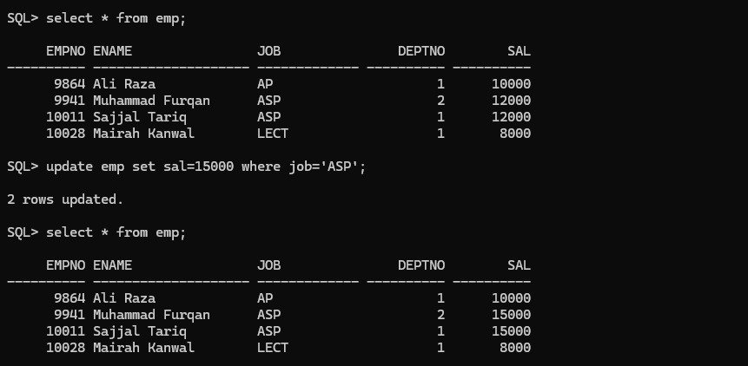

Q2: Create a pseudo (copy) table employee with the same structure as the table emp and insert rows into the table using select clauses.
Answer:
SQL> create table employee as select * from emp;
Table created.
SQL> desc employee;

Name Null? Type
----------------- -------- ----------------------------
EMPNO NUMBER(6)
ENAME NOT NULL VARCHAR2(20)
JOB NOT NULL VARCHAR2(13)
DEPTNO NUMBER(3)
SAL NUMBER(7, 2)
Code:
create table employee as select * from emp;
desc employee;
Output:
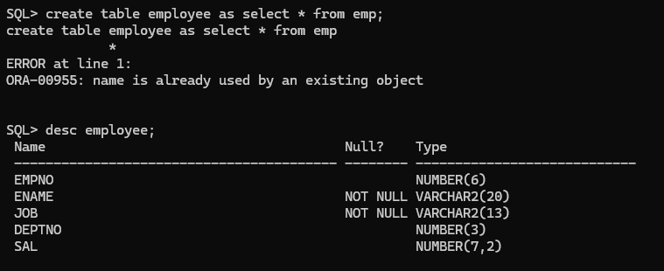

Then:
create table employee as select * from emp where 1=0;
insert into employee select * from emp;

Output:
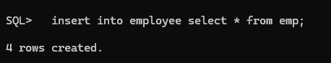

Q3: select employee name, job from the emp table;
Answer:
SQL> select ename, job from emp;
ENAME JOB
---------- --------------------
Mehboob AP
Ali ASP
Gulfam ASP
Kareem PROF
Ayesha AP
Saqib LECT

6 rows selected.

Code:
select ename, job from emp;

Output:
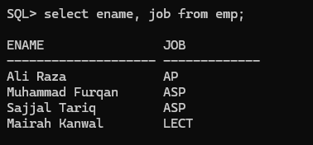

Q4: Delete only those who are working as lecturer.
Answer:
SQL> select * from emp;
EMPNO ENAME JOB DEPTNO SAL
---------- -------------------- ------------- ---------- ----------
1 Mehboob AP 1 10000
2 Ali ASP 2 15000
3 Gulfam ASP 1 15000
4 Kareem PROF 2 30000
5 Ayesha AP 1 10000
6 Saqib LECT 1 8000

6 rows selected.

Code:
select * from emp;
delete from emp where job='LECT';
select * from emp;
commit;

Output:
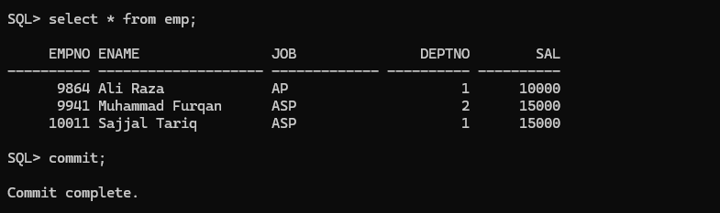

Q5: List the records in the emp table order by salary in ascending order.
Answer:
SQL> select * from emp order by sal;

EMPNO ENAME JOB DEPTNO SAL
---------- -------------------- ------------- ---------- ----------
1 Mehboob AP 1 10000
5 Ayesha AP 1 10000
2 Ali ASP 2 15000
3 Gulfam ASP 1 15000
4 Kareem PROF 2 30000

5 rows selected.
Code:
select * from emp order by sal;
Output:
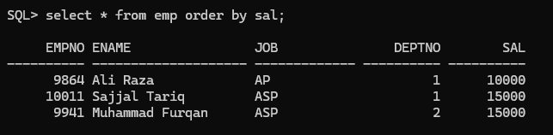

Q6: List the records in the emp table order by salary in descending order.
Answer:
SQL> select * from emp order by sal desc;

EMPNO ENAME JOB DEPTNO SAL
---------- -------------------- ------------- ---------- ----------
4 Kareem PROF 2 30000
2 Ali ASP 2 15000
3 Gulfam ASP 1 15000
1 Mehboob AP 1 10000
5 Ayesha AP 1 10000

Code:
select * from emp order by sal desc;
Output: 